Module Assignment: File I/O with Arrays
Name | Zachary White
Instructor | Darrell Payne
Course | CSD 420
Date | 08/20/2026
Assignment | Module Assignment – File I/O with Arrays (Random Integers and Doubles)

Assignment Overview
This assignment required writing two Java programs that work together through a shared binary data file named Zwhitedatafile.dat. The first program, WriteRandomData.java, generates an array of five random integers and an array of five random double values, then writes both arrays to the data file. If the file does not already exist it is created automatically; if it already exists, the new data is appended to the end of the file instead of overwriting what is already there. The second program, ReadRandomData.java, opens the same data file and reads the values back out, displaying every batch of data that has been written to the file so far.

Program 1: WriteRandomData.java
This program uses java.util.Random to fill an int[] of size five with random integers between 0 and 999, and a double[] of size five with random values between 0.0 and 100.0 (rounded to two decimal places). Both arrays are then written to Zwhitedatafile.dat using a DataOutputStream layered over a FileOutputStream. The append behavior is controlled entirely by how the FileOutputStream is opened:
FileOutputStream fos = new FileOutputStream(FILE_NAME, true);
Passing true as the second constructor argument tells Java to open the file in append mode. If Zwhitedatafile.dat does not exist yet, this same call creates it; if it does exist, writing begins at the end of the existing content rather than replacing it. After writing, the program prints the five integers and five doubles it just wrote to the console so the values can be visually confirmed.

Program 2: ReadRandomData.java
This program opens Zwhitedatafile.dat using a DataInputStream layered over a FileInputStream. Because WriteRandomData.java may be run multiple times, appending a new batch of five integers and five doubles on every run, ReadRandomData.java reads the file in a loop, pulling one batch (5 ints + 5 doubles) out at a time and printing it as “Batch 1,” “Batch 2,” and so on. The loop relies on the fact that DataInputStream.readInt() and readDouble() throw an EOFException once there is no more data left in the file that exception is caught deliberately and used as the normal, expected signal to stop reading and report the total number of batches found.

Testing Performed
The following tests were carried out to confirm the programs meet every requirement of the assignment:
- Compiled both WriteRandomData.java and ReadRandomData.java with javac and confirmed there were no compiler errors.
- Ran WriteRandomData.java when Zwhitedatafile.dat did not yet exist, confirming the file was created automatically.
- Ran WriteRandomData.java a second time and confirmed the file size grew (60 bytes -> 120 bytes), proving new data was appended rather than overwriting the file.
- Ran ReadRandomData.java and confirmed it displayed both batches of data in the order they were written, with values matching exactly what each write step had printed.
- Used the dir command (Windows Command Prompt) to inspect Zwhitedatafile.dat directly and confirm its final size of 120 bytes, matching the expected total for two batches of five 4-byte integers and five 8-byte doubles (5×4 + 5×8 = 60 bytes per batch).

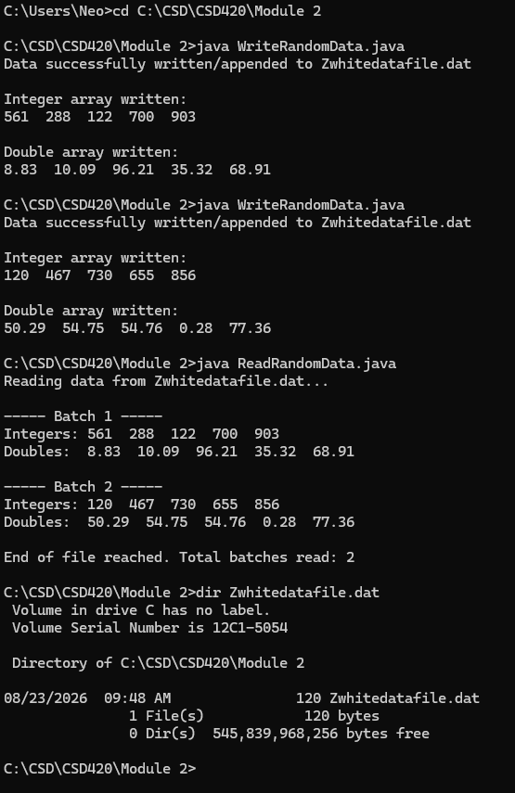
Program Execution and Output
The screenshot shows the full workflow run from the Windows Command Prompt in the project directory (C:\CSD\CSD420\Module 2). WriteRandomData.java is compiled and run twice in succession, producing two independent batches of five random integers and five random doubles appended to Zwhitedatafile.dat. ReadRandomData.java is then run and correctly displays both batches, in the order they were written, confirming that append mode preserved the prior data. The final dir listing confirms the data file is exactly 120 bytes, matching the expected size for two batches of five 4-byte integers and five 8-byte doubles.

Conclusion
Both programs function correctly and satisfy every requirement of the assignment: an array of five random integers and an array of five random doubles are generated and stored; the data is written to Zwhitedatafile.dat, with the file being created automatically if it does not exist and appended to if it does; and a second program reads the file back and displays its contents accurately. Repeated test runs confirmed that append mode preserves all previously written data and that the reader program correctly reconstructs and displays every batch present in the file.

Sources

- Liang, Y. D. (2022). Introduction to Java programming and data structures (13th ed.). Pearson.

- Related course materials for module 2. (Bellevue University)

